**VoiceIQ Technical Evaluation**

**Execution Steps**

1. Run ‘npx create-react-app’ in a command prompt.
2. Remove unnecessary files like logo.svg, index.css, test related files, etc. and their dependencies (this step is **optional**).
3. Import ‘Bootstrap’ in ‘index.html’ file.

*<!-- Include Bootstrap -->*

*<link href="https://cdn.jsdelivr.net/npm/bootstrap@5.0.0-beta1/dist/css/bootstrap.min.css" rel="stylesheet" integrity="sha384-giJF6kkoqNQ00vy+HMDP7azOuL0xtbfIcaT9wjKHr8RbDVddVHyTfAAsrekwKmP1" crossorigin="anonymous">*

1. Copy the following files from the given ‘GitHub Repository’.

*Under ‘src’ folder:*

*App.js*

*App.css*

Create a folder called ‘components’ inside the ‘src’ folder and copy following files there.

*AddComment.js*

*Comments.js*

1. In the ‘VS Code - terminal’, type ‘npm start’ and press enter to run the application.

N.B:- **No need to install any external packages** (like redux, axios, uuid, etc.) in order to run this application.

Once the setting up is done, if you open the project in ‘VS Code’ it will look like this.

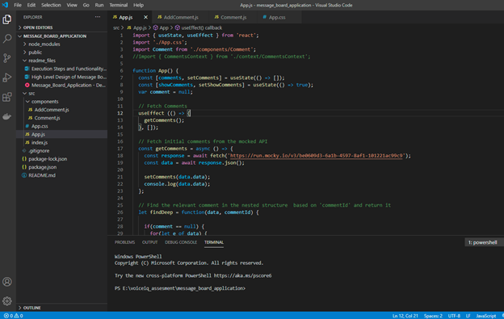

**Functionality Breakdown**

At the initial rendering the screen will look like this.

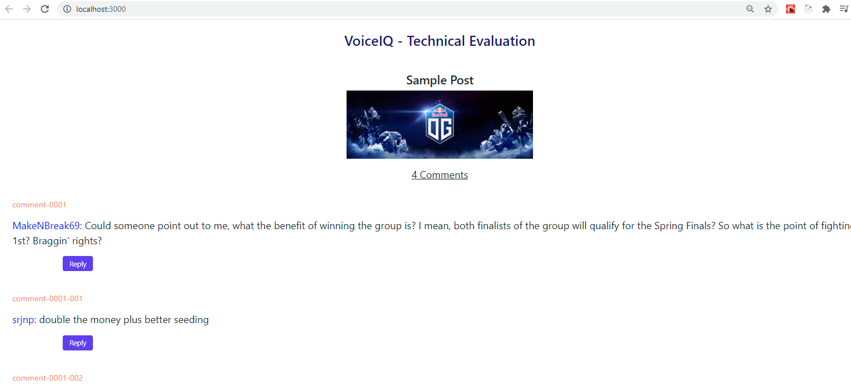

You can show / hide the ‘comments’ by clicking at the following text.



Initially all the comments will be displayed by default and upon clicking the above text, the screen will look like below. You can click on the text again to view the comments.

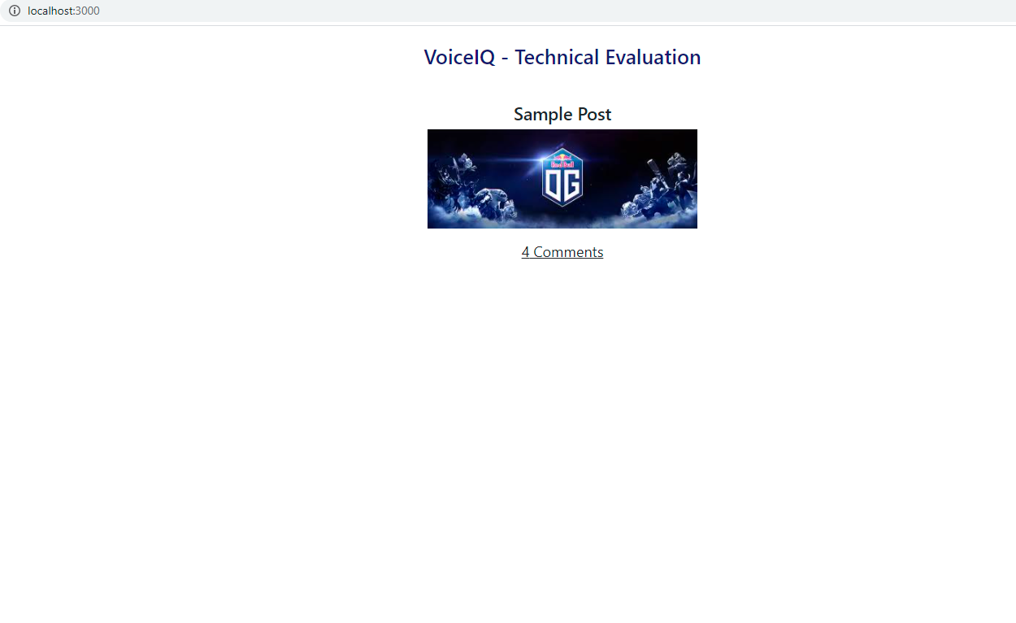

**‘Comments’ Section Explained:**

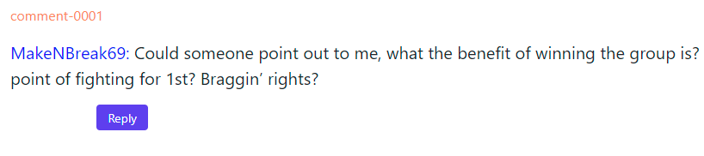

Here the ‘comment Id’ is displayed in ‘orange’ like font (even though I initially added it here for testing purposes, I let it as it is because it makes things easy when it comes to identify newly added comments). Comment Id follows the same pattern that is used in the ‘Mocked API’.

Comment Id is followed by the ‘User’s Name’ who inserted the comment (in blue font) and the actual ‘Comment’ itself. Then there is a ‘Reply’ button and when you click on that it will display the ‘Add Comments’ section as shown below.

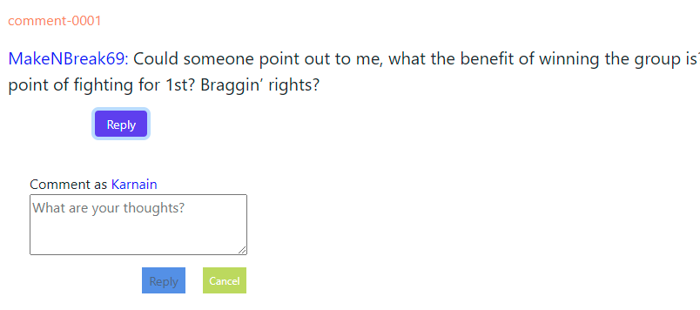

‘Add Comments’ section consists of a text area where you can enter your comments, a ‘Reply’ button and a ‘Cancel’ button.

‘Cancel’ button will clear the text (if you have entered any) and hides the ‘Add Comments’ section.

‘Reply’ button is initially disabled and it will be enabled once you enter a text in the text area. You can click on the ‘Reply’ button to save your comment / reply.

Upon clicking on the ‘Reply’ button, the newly inserted comment will be display at the top of the replies thread (please note that I have hard-coded myself as the current logged-in user).

